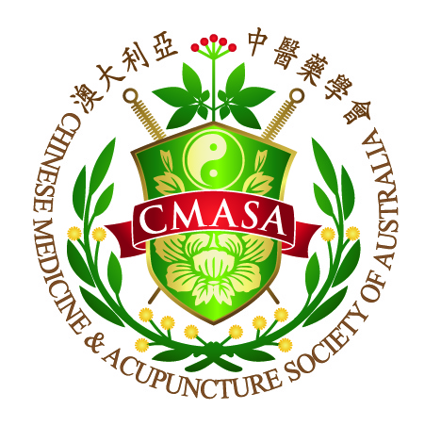

**Continuing Professional Development**

**CPD 20___**

|  |  |
| --- | --- |
| Name ___________________ | Signature ________________ |
| CMBA ___________________ | CMASA _________________ |
| Address _________________________________________________________ | |
| State __________________ | Postcode ________________ |
| Email____________________________________________________________ | |
| Period 1st December 20__ to 30th November 20__ | |

As one of the standards for registration renewal, CMBA requires a minimum

annual requirement of 20 hours, please refer to below for more details:

Chinese Medicine Continuing Professional Devwelopment Registration Standard

http://www.chinesemedicineboard.gov.au/Registration-Standards.aspx

Please send this record back to CMASA before 31st of December 2015

Preferably, please send scanned record by email at

cmasatcm@hotmail.com

However mail or fax is acceptable.

CHINESE MEDICINE & ACUPUNCTURE SOCIETY OF AUSTALIA LTD

ABN 46 086 774 996

P.O. Box 1323 Burwood NSW 1805

Phone: (02) 9727 6831 Fax: (02) 9727 8981

Email: cmasatcm@hotmail.com

Website: <www.cmasa.org.au>

**Annual Development Plan**

|  |  |
| --- | --- |
| Goals / Learning Objectives | Outcomes |
|  |  |
|  |  |
|  |  |
|  |  |

**Total CPD for the year 20___**

|  |  |
| --- | --- |
| **CPD Category** | **CPD Hours** |
| Formal Activities ( minimum 14 hrs ) |  |
| Informal Activities ( maximum 6 hrs ) |  |
| Activities relating to Professional Issues ( 4 hrs ) |  |
| Activities relating to scheduled herbs endorsement  ( minimum 2 hrs if applicable ) |  |
| **TOTAL ( Minimum 20 hrs per year )** |  |

|  |  |  |
| --- | --- | --- |
| Date: Attachment [ ]  Organiser:    Topic:    Activity:  Reflection： | **CPD** | |
| Formal |  |
| Informal |  |
| Professional  Issues |  |
| Date: Attachment [ ]  Organiser:    Topic:  Activity:  Reflection： | **CPD** | |
| Formal |  |
| Informal |  |
| Professional  Issues |  |
| Date: Attachment [ ]  Organiser:    Topic:  Activity:  Reflection： | **CPD** | |
| Formal |  |
| Informal |  |
| Professional  Issues |  |
| Date: Attachment [ ]  Organiser:  Topic:    Activity:    Reflection： | **CPD** | |
| Formal |  |
| Informal |  |
| Professional  Issues |  |
| Date: Attachment [ ]  Organiser:    Topic:    Activity:  Reflection： | **CPD** | |
| Formal |  |
| Informal |  |
| Professional  Issues |  |
| Date: Attachment [ ]  Organiser:    Topic:  Activity:  Reflection： | **CPD** | |
| Formal |  |
| Informal |  |
| Professional  Issues |  |
| Date: Attachment [ ]  Organiser:    Topic:  Activity:  Reflection： | **CPD** | |
| Formal |  |
| Informal |  |
| Professional  Issues |  |
| Date: Attachment [ ]  Organiser:  Topic:    Activity:    Reflection： | **CPD** | |
| Formal |  |
| Informal |  |
| Professional  Issues |  |
| Date: Attachment [ ]  Organiser:    Topic:    Activity:  Reflection： | **CPD** | |
| Formal |  |
| Informal |  |
| Professional  Issues |  |
| Date: Attachment [ ]  Organiser:    Topic:  Activity:  Reflection： | **CPD** | |
| Formal |  |
| Informal |  |
| Professional  Issues |  |
| Date: Attachment [ ]  Organiser:    Topic:  Activity:  Reflection： | **CPD** | |
| Formal |  |
| Informal |  |
| Professional  Issues |  |
| Date: Attachment [ ]  Organiser:  Topic:    Activity:    Reflection： | **CPD** | |
| Formal |  |
| Informal |  |
| Professional  Issues |  |
| Date: Attachment [ ]  Organiser:    Topic:    Activity:  Reflection： | **CPD** | |
| Formal |  |
| Informal |  |
| Professional  Issues |  |
| Date: Attachment [ ]  Organiser:    Topic:  Activity:  Reflection： | **CPD** | |
| Formal |  |
| Informal |  |
| Professional  Issues |  |
| Date: Attachment [ ]  Organiser:    Topic:  Activity:  Reflection： | **CPD** | |
| Formal |  |
| Informal |  |
| Professional  Issues |  |
| Date: Attachment [ ]  Organiser:  Topic:    Activity:    Reflection： | **CPD** | |
| Formal |  |
| Informal |  |
| Professional  Issues |  |